**Assignment#02**

**SYSTEM REQUIRMENT SPECIFICATIONS (SRS)**

**SUBMITTED BY: MUZAMMIL NOOR.**

**SUBMITTED TO: MR.KAMRAN**

**REG# FA17-BSE-O64 (5B).**

**DATED: 12th NOV, 2019.**

**PROJECT: TRAVEL AGENCY SYSTEM.**

**SUBJECT: Software Quality Engineering.**

Table of Contents

1.1 Purpose of this Document : 2

1.2 Scope : 2

2. GENERAL DESCRIPTION 3

2.1 Product Description: 3

2.1.1 Overview 3

2.1.2 Transfer Capabilities 3

2.1.3 On-line Help 3

2.1.4 Setup Documentation 4

2.2 User Characteristics 4

2.3 Operating Environment 4

2.4 General Constraints 5

2.4.1 Language 5

2.4.2 Software 5

2.4.3 Operating System 5

2.4.4 Communication Protocols 5

3. SPECIFIC REQUIREMENTS 5

3.1 Installation 5

3.2 On-line help 6

3.3 Interface: 6

3.4 Login Procedure 7

3.5 Protocol Determination 8

3.6 Directory Navigation 9

3.7 File Transfer 10

4. REQUIREMENTS VALIDATION 11

4.1 Client Validation 11

4.2 Testing 12

4.3 Prototyping 12

5. CONCLUSION 12

Glossary: 14

**1. INTRODUCTION:**

## 1.1 Purpose of this Document:

This document is given in order to make sure that the software we produce will be agreeing with matching up, with working regularly with the needs of our client. It is a description of the project needed things that we have been given. Stating these needed things clearly and definitely helps insure that any possible miscommunications are dealt with at an early stage, when the cost of starting changes is still low.

This document is divided into more than two, but not a lot of sections. The following section will present a general description of the product that we are working on. The focus will then be narrowed in the next section to deal with particular needed things. There will then be a section explaining the processes that we will employ to secure make sure of the quality of our product. Finally, there will be a summary of the project .We encourage our client to distribute this document among their travel agents and management in order to provide us with (reactions or responses to something helpful returned information). This will help us secure make sure of that our end product fully meets their needs. This document will also be a useful thing valuable supply for those who l be upgrading or maintaining the software after it has been completed.

## 

## 1.2 Scope:

A piece of software entitled "Trip" will be our final very best product. This software will help the work of travel agents by allowing them to connect to remote servers and move from one place to another computer files to or from their own computers. These complex processes will be easily completed by means of an point-and-click connecting point way of interacting with something. It will also allow the travel agents to set their computers to automatically move (from one place to another) many large computer files overnight so that they will be available for careful reading in the morning.

# **2. GENERAL DESCRIPTION**

**In general description we are discussing some features of travel agency system.**

## **2.1 Product Description:**

**There are many points which are discussing in this system specification.**

**We also display diagrams in this document.**

### **2.1.1 Overview**

**This software will enable travel agents to get rid of the paper information brochures that they have to take in from tour companies by downloading computerized versions of these brochures directly from the devices of the tour companies. This will cut down paper expenditures and will also raise the accessibility of data that is saved at locations which are difficult to approach.**

### **2.1.2 Transfer Capabilities**

**The travel agents will make use of our software to join up with former remote servers holding the needed files. The agents, by the help of a simple graphical user interface (GUI) will be able to see what files are contained on these remote servers, download the desired files or upload subsequent new files. If they want, they will also be having procedures to list up the files that they would wish to move automatically. This will help them transfer files to and from their computers overnight, on the assumption that the transferring is sluggish or the files that are to be downloaded are voluminous.**

### **2.1.3 On-line Help**

**An on-line help system will be maintained with the software to provide as reference. It will also help new users learn to operate the program. The help system will comprise of Frequently Asked Questions (FAQs), a full-fledge guide to carrying out all steps of the program and a Live Contact feature which will enable users to seek help from professionals.**

### **2.1.4 Setup Documentation**

**Documentation will be presented on how to install the software and how to access the information on various key features of the software from the on-line help system.**

## **2.2 User Characteristics**

**The travel agents who will be operating our software should have a necessary familiarity with personal computers, a preliminary comprehension of the software and an operative knowledge of systems with graphical user interfaces (GUIs). However, the travel agents are not obligated to have any awareness of networking or file transfer procedures. The only necessary and specific discernment the travel agents are required to have is the name of the server that is needed to be connected, a login user name and a password if the security configuration of the particular remote serve requests it.**

## **2.3 Operating Environment**

**The system is fashioned to run under X-Windows and Windows /NT based personal computers. There ought to be an operative network connecting the travel agents and the tour company's servers. The travel agents' computers will be upgraded by the client to assure that they are competent enough to run our software properly. It will offer a minimum resolution of 800x600 pixels and the capacity to run Java v1.2 programs. The remote servers that the files will be downloaded from or uploaded to should be having any of the fore mentioned operating systems, but they must be running the required server software (which will be offered by the client).**

## **2.4 General Constraints**

### **2.4.1 Language**

**To ease the usage and increase the effectiveness of the software, the set language is English only. It makes the software user friendly, comprehensive and professional.**

### **2.4.2 Software**

**The software is mapped out using JDK 1.2. It will be run using JDK 1.2 as well.**

### **2.4.3 Operating System**

**The software will proceed on X-Windows or Windows 9x NT. These are the minimum and necessary demands of operating system.**

### **2.4.4 Communication Protocols**

**The remote servers containing the relevant files should be able to use at least one of these communication protocols:**

* **File Transfer Protocol**
* **Telnet**
* **Windows File Sharing**

# **3. SPECIFIC REQUIREMENTS**

## **3.1 Installation**

* **Instructions on ‘how to install’ the system shall be orchestrated and provided with the software.**
* **The system shall be administered with a proper installation mechanism.**

## **3.2 On-line help**

**The need for on-line help is always when installing or operating a system. Thus, it will come with this facility to ensure better user guide.**

## **3.3 Interface:**

**3.3.1 The system will have a handy and simple, easy to use GUI.**

**3.3.2 Another scintillating feature is that the GUI will be yielding a response to the user. It will certainly help the users take cooperative and constructive steps.**

**3.3.3 The GUI will enable and allow directory navigation on the travel agents’ computers.**

**3.3.4 Moreover, it will grant directory navigation of the remote servers too. Thus, it will assure an uncomplicated link.**

**3.3.5 File transfers will be made possible by GUI without any trouble or security hindrances.**

**For example airline reservation system:**

**In this system all bookings are online so we made things easy in these days for our new generation.**

**3.3.6 You can check below diagram:**

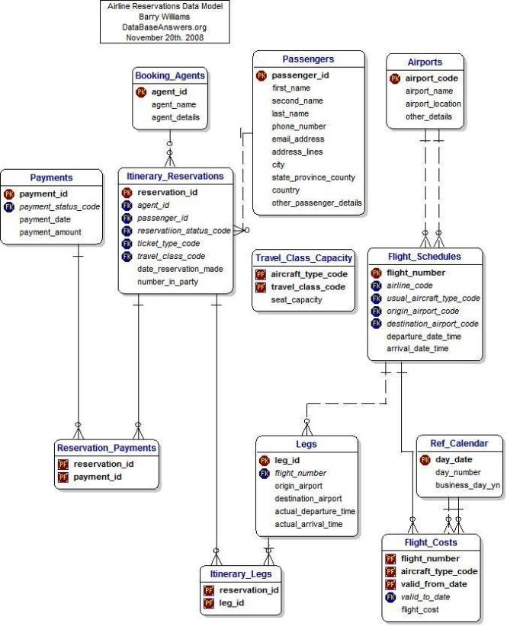

## **3.4 Login Procedure**

**The system’s most important feature is that it will require the users to enter their name or the address of the particular remote server.**

**3.4.2 The system shall scheme an error message when it is unable to connect to the provided credentials or address.**

**3.4.3 The system enables the users to set desired usernames and passwords when they like to connect to the servers.**

**3.4.4 The typed password will not be displayed on-screen to ensure user’s privacy and unique identity when he wishes to connect.**

**3.4.5 Another error message shall be displayed if the provided username and password are not correspondent.**

**3.4.6 A tentative list of the most recently and most frequently connected remote servers and the usernames used to access those servers will be credited to the users instantaneously.**

## **3.5 Protocol Determination**

**3.5.1 As mentioned above, the system shall be enabled to connect to remote servers using any of the following communication protocols:**

* **File Transfer Protocol**
* **Telnet**
* **Windows File Sharing**

**3.5.2 As per the default settings, it will be automatically selected which protocol to use when communicating with a remote server.**

**3.5.3 Intuitively, the server will show a message when file transfer from the remote server cannot take place.**

## **3.6 Directory Navigation**

**3.6.1 The system shall show a congregation of files and directories in the current directory of the user’s computer.**

**3.6.2 The system will present a list of files and directories in the current catalogue ofany remote server that the system is connected to.**

**3.6.3 The system shall display the following properties of each file and directory:**

**Name, date modified and size.**

**3.6.4 The system shall enable the user to classify the records of a directory by name.**

**3.6.5 The current directory can be changed by the users. This is another custom user friendly feature.**

**3.6.6. The changed directory among many others can also be selected default by the user themselves.**

**3.6.7 To ensure security and privacy yet again, the system will scheme an error notification if the user is not allowed to access the default, local or remote records or directories.**

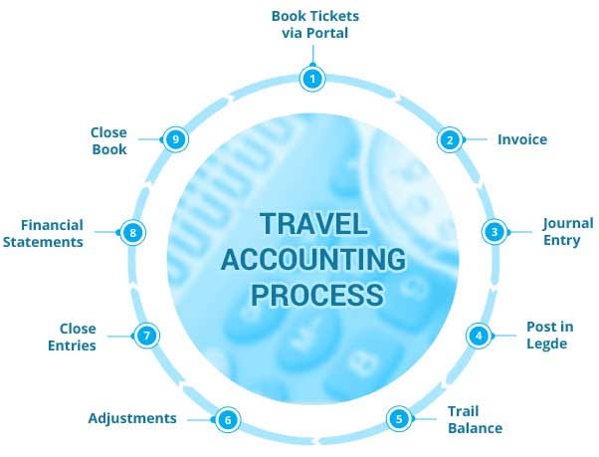

## **3.7 File Transfer**

**3.7.1 The system shall allow users to select one or more files or directories from thecurrent directories of the remote server or the local computer to be transferred.**

**3.7.2 The system shall allow users to choose to transfer selected items immediately or after some time.**

**3.7.3 The system will display the items selected for transfer in a list arranged by priority.**

**3.7.4 The system will allow users to reset or change the list of items to transfer by eliminating them, adding them or rearranging the catalogue.**

**3.7.5The system shall display the progress of the current transfer.**

**3.7.6 The system shall permit users to pause and resume transfers while they are in progress.**

**3.7.8 The system will transfer items from the remote server into the current folder on the local computer.**

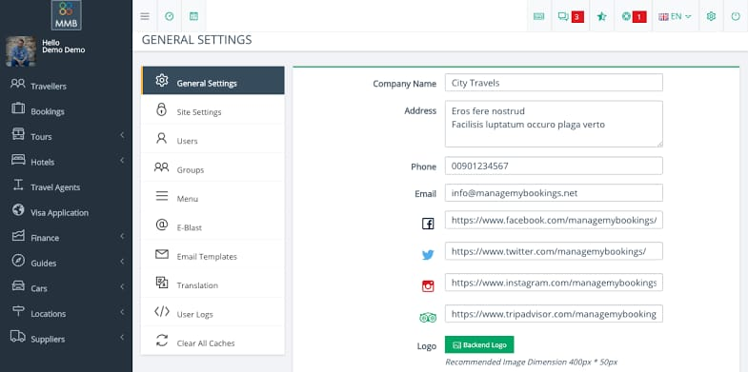

# **4. REQUIREMENTS VALIDATION**

## **4.1 Client Validation**

**We request the client to review these requirements, document them and present it to its travel agents. This will take the client into confidence and also ensure our perception that what we provided was desired actually. We welcome all the requests and demands for additions, supplementations or omissions at this time precisely because it will be difficult to process in later stages.**

## **4.2 Testing**

* **Connecting to the remote servers and attempting to carry out all of the operations that our program is required to perform.**
* **Transferring many different types of files to and from local computers and remote servers.**
* **Making sure that our program functions well when problems occur such as external interruptions in network and trying to log in using incorrect login information.**
* **Transferring using all of the supported communications protocols.**
* **Ensuring that our product functions under all of the supported operating systems.**

## **4.3 Prototyping**

**We will give the client some working prototypes of less functionality at various blocks of the production process. This will help the client to have a comprehension and awareness of our product, meanwhile**

**also giving us required useful feedback.**

# **5. CONCLUSION**

**It is our desire and utmost aspiration that this document will be the first part of a series of exchanges between us and the client. This will help the client review the important features of our product, the vision and effort behind. It will be significant to indulge the travel agents in this feedback, as end-users, they often have many momentous perceptions that might not be familiar to software developers or people in management. This will be a way of ensuring that the requirements presented by the client are fulfilled timely. We look forward to a positive response and experience to learn.**

# **Glossary:**

**FTP**

**File Transfer Protocol. A standard way to transfer files between computers.**

**Graphical User Interface:**

**An interface between the user and a piece of software that**

**allows him or her to interact with the program using a mouse, windows, dialogue boxes**

**menus , buttons.**

**Java Code:**

**A language that programmers use to write software.**

**Linux:**

**An operating system that is an alternative to Microsoft Windows.**

**Log File:**

**A file that contains a list of actions performed by a computer.**

**On-Line Help System:**

**A reference on how to use our product that will be made**

**Available by choosing an item from a menu in our software.**

**Remote Servers:**

**Computers at arbitrary locations that the users of our product will be**

**Able to connect to using telecommunications. These computers will hold the files that the**

**Travel agents will want to download.**

**Running:**

**The process of using a particular piece of software.**

**Server Software:**

**The software that enables computers to work as remote servers.**

**Upgrading Software:**

**The process of creating a new version of a piece of software with**

**Increased functionality and or improved performance.**

**Windows File Sharing:**

**A means of transferring files that comes standard with Microsoft windows.**

**X-Windows:**

**An application for UNIX and Linux which greatly aids in the creation and**

**Standardization of graphical user interfaces.**